# Assumption check for multiple regression

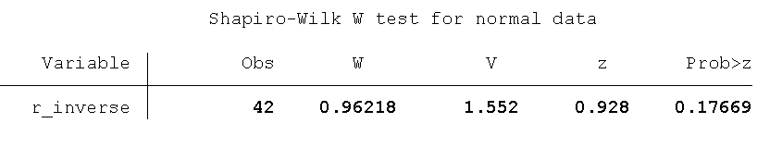

Table 1: Shapiro-Wilk W test for normality test

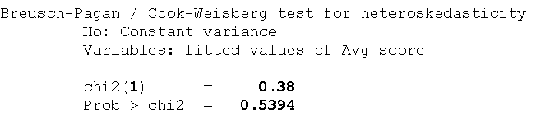

Table 2: Breusch-Pagan test for heteroscedasticity

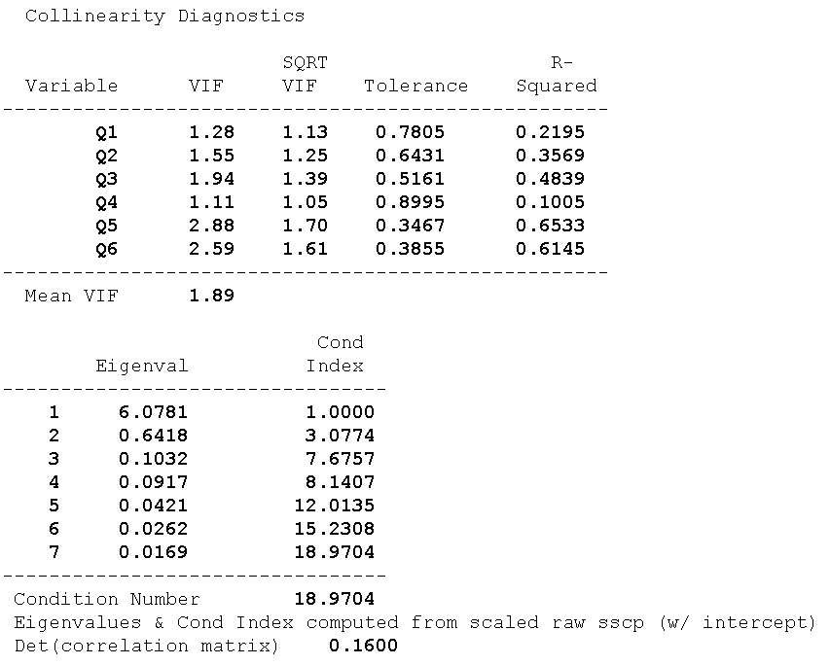

Table 3: Collinearity diagnostics

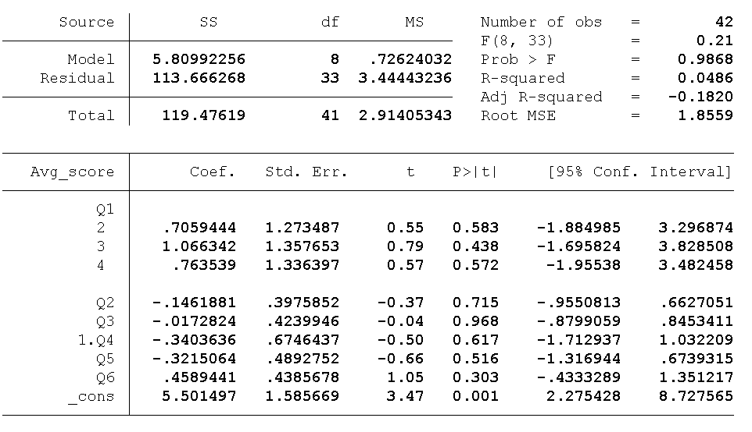

Table 4: Multiple regression

# Fisher’s exact test of personal factors between groups

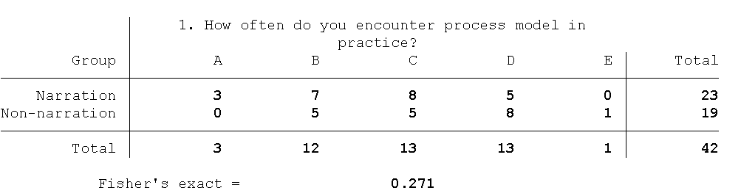

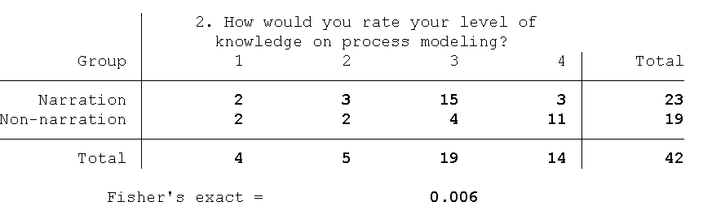

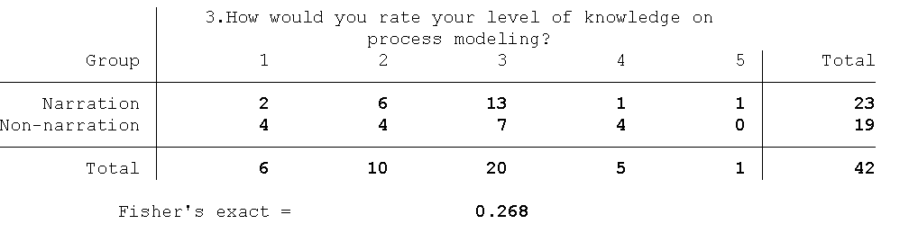

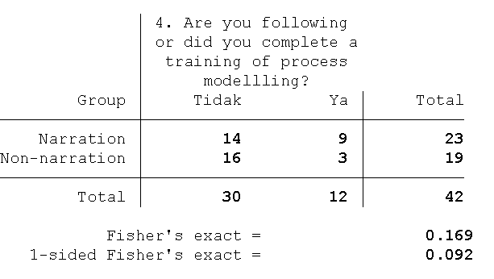

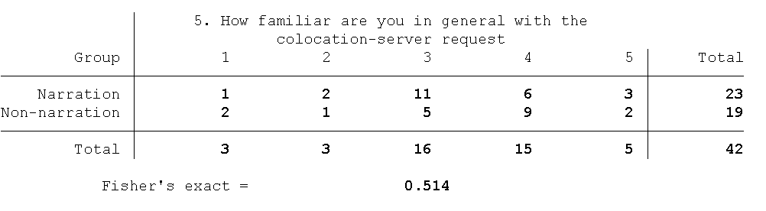

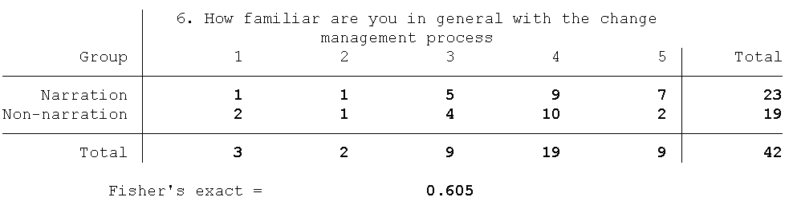

# Assumptions check and influence of treatment types on score (% correct answers)



Table 5: Normality test for total correct answer (for all groups)



Table 6: Normality check for total correct answers (between groups)



Table 7: Homogeneity check for % correct answers (between groups)



Table 8: Two independent sample t-test for %correct answer (between groups)

# Assumptions check and influence of treatment types for each process model on score (% correct answers)



Table 9: Normality test for % total correct answers (for each treatment type and process models)



Table 10: Skewness and Kurtosis test for Normality (Group of Narration, Change Management process model)



Table 11: Homogeneity check for % total correct answer (Colocation process model)



Table 12: Homogeneity check for % total correct answers (Change Management process model)



Table 13: Independent t-test for % correct answer (for Colocation process model)



Table 14: Mann-Whitney U test for %correct answer (for Change management process model)

# Assumptions check for PU, PEOU, and CLE



Table 15: Normality test of PU, PEOU, and CLE



Table 16: Homogeneity of variances test for Perceived Usefulness (PU)



Table 17: Homogeneity of variances test for Perceived Ease of Use (PEOU)



Table 18: Homogeneity of variances test for Content and Learning Experience (CLE)

# The influence of treatment types on PU, PEOU, and CLE



Table 19: Two independent sample t-test for Perceived Usefulness



Table 20: Two independent sample t-test for Perceived Ease of Use



Table 21: Two independent sample t-test (unequal variances) for Content and Learning Experience

# The influence of treatment types on different type of questions



Table 22: Sphericity assumption using Mauchly’s test for the narration group



Table 23: Repeated measures (within subject) ANOVA for the narration group



Table 24: Pairwise comparison for the narration group



Table 25: Sphericity assumption using Mauchly’s test for the non-narration group



Table 26: Repeated measures (within subject) ANOVA for the non-narration group



Table 27: Pairwise comparison for the non-narration group

# Comparison of each type of questions between groups



Table 28: Shapiro-Wilk normality test of each question types and treatment types



Table 29: Homoscedasticity test for each type of question between groups



Table 30: Independent t-test with equal variances for question type F (Flow)



Table 31: Mann-Whitney U test for question type R (Resources)



Table 32: Independent t-test with equal variances for question type RF (Resources and Flow)



Table 33: Independent t-test with equal variances for question type I(Information) / FI (Flow and Information)